C:\Users\jeffrey_bale\AppData\Local\Microsoft\Windows\Temporary Internet Files\Content.IE5\NL38EUKV\MC900127674[1].wmfEquilibrium Prices and Equilibrium Quantities

Below you’ll find a Demand and Supply schedule for Burritos. Plot the data on the axes provided for you. Make sure you label all elements. Demand curves should be labeled D (D1, D2, D3, etc.) while Supply curves should be labeled S (S1, S2, S3, etc.). All equilibrium points should be labeled E (E1, E2, E3, etc.).

|  |  |  |
| --- | --- | --- |
| Price ($ per Burrito) | Quantity Demanded (millions) | Quantity Supplied (millions) |
| $1.00 | 300 | 100 |
| $2.00 | 250 | 150 |
| $3.00 | 200 | 200 |
| $4.00 | 150 | 250 |
| $5.00 | 100 | 300 |

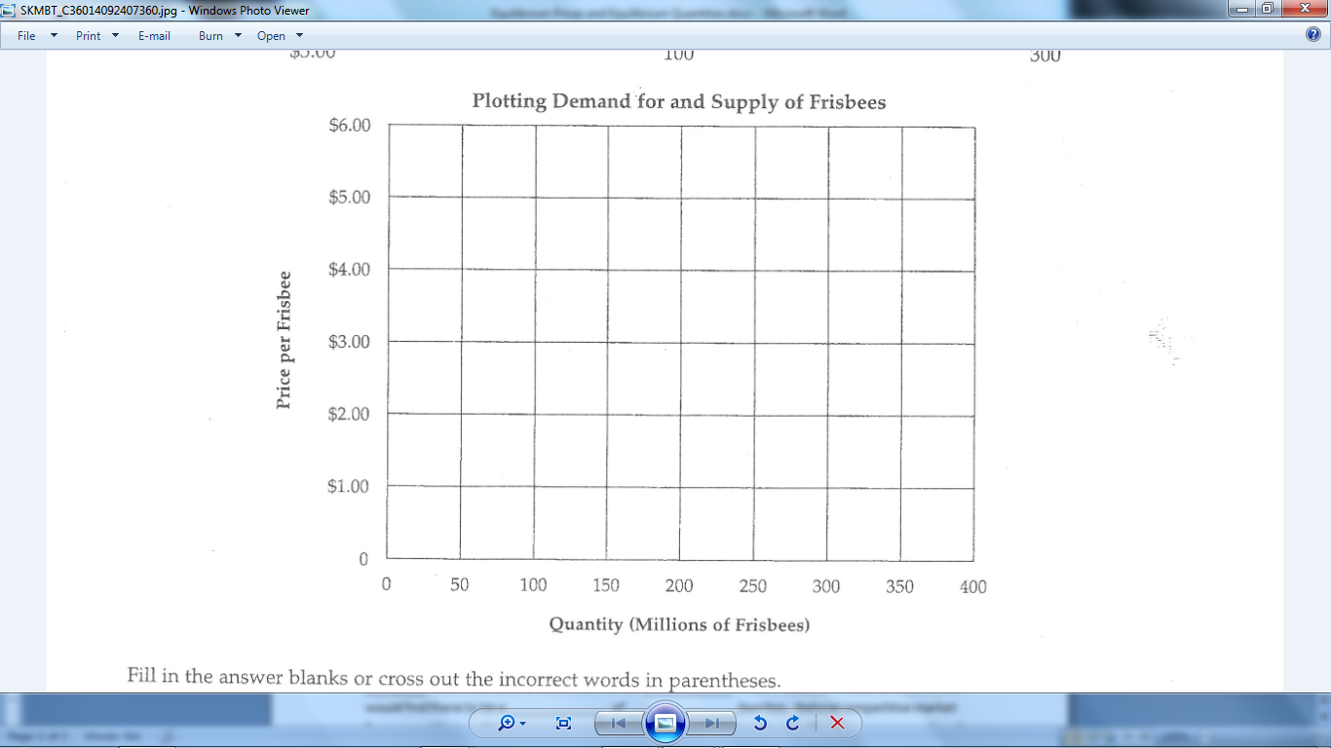

Fill in the answer blanks for the following:

A. Under the conditions shown, competitive market forces would tend to establish an equilibrium price of $\_\_\_\_\_\_\_\_\_ per Burrito and an equilibrium quantity of \_\_\_\_\_\_\_\_\_\_ million Burritos.

B. If the price currently prevailing on the market is $4.00 per Burrito, buyers would want to buy \_\_\_\_\_\_\_\_ million and sellers would want to sell \_\_\_\_\_\_\_\_\_\_\_\_ million. Based on these conditions, we would find there to be a \_\_\_\_\_\_\_\_\_\_\_\_\_ of \_\_\_\_\_\_\_\_\_\_\_\_\_\_\_ burritos. Natural competitive market forces would act on this price and force the prevailing market price down to $\_\_\_\_\_\_\_\_\_\_\_\_ per burrito.

*Change in Supply of Burritos*

|  |  |
| --- | --- |
| Price ($ per Burrito) | Quantity Supplied (millions) |
| $2.00 | 50 |
| $3.00 | 100 |
| $4.00 | 150 |
| $5.00 | 200 |

Plot the new supply schedule on the original graph and label it S2. Label the new equilibrium as well. Under these new conditions we would find that competitive market forces would tend to establish an equilibrium price of $\_\_\_\_\_\_\_\_\_\_ per burrito with an equilibrium quantity of \_\_\_\_\_\_\_\_\_\_ million.

*Change in Demand for Burritos*

|  |  |
| --- | --- |
| Price ($ per Burrito) | Quantity Supplied (millions) |
| $1.00 | 200 |
| $2.00 | 150 |
| $3.00 | 100 |
| $4.00 | 50 |

Plot the new demand schedule on the original graph and label it D2. Label the new equilibrium as well. Under these new conditions we would find that competitive market forces would tend to establish an equilibrium price of $ \_\_\_\_\_\_\_\_\_\_\_\_ per burrito with an equilibrium quantity of \_\_\_\_\_\_\_\_\_\_\_\_ million.

If the market price for burritos is currently $1.75 per burrito, we can expect competitive market forces to result to do what? What would explain such forces?

\_\_\_\_\_\_\_\_\_\_\_\_\_\_\_\_\_\_\_\_\_\_\_\_\_\_\_\_\_\_\_\_\_\_\_\_\_\_\_\_\_\_\_\_\_\_\_\_\_\_\_\_\_\_\_\_\_\_\_\_\_\_\_\_\_\_\_\_\_\_\_\_\_\_\_\_\_\_\_\_\_\_\_\_\_\_\_\_\_\_\_\_\_\_\_\_\_\_\_\_\_\_\_\_\_\_\_\_\_\_\_\_\_\_\_\_\_\_\_\_\_\_\_\_\_\_\_\_\_\_\_\_\_\_\_\_\_\_\_\_\_\_\_\_\_\_\_\_\_\_\_\_\_\_\_\_\_\_\_\_\_\_\_\_\_\_\_\_\_\_\_\_\_\_\_\_\_\_\_\_\_\_\_\_\_\_\_\_\_\_\_\_\_\_\_\_\_\_\_\_\_\_\_\_\_\_\_\_\_\_\_\_\_\_\_\_\_\_\_\_\_\_\_\_\_\_\_\_\_\_\_\_\_\_\_\_\_\_\_\_\_\_\_\_\_\_\_\_\_\_\_\_\_\_\_\_\_\_\_\_\_\_\_\_\_\_\_\_\_\_\_\_\_\_\_\_\_\_\_\_\_\_\_\_\_\_\_\_\_\_\_\_\_\_\_\_\_\_\_\_\_\_\_\_\_\_\_\_\_\_\_\_\_\_\_\_\_\_\_\_\_\_\_\_\_\_\_\_\_\_\_\_\_\_\_\_\_\_\_\_

Following Price

Assuming we don’t have any data on a product, we can still make estimates about how a price may or may not fluctuate by examining various shifts in supply and demand. Analyzing such shifts gives us great insight into why products may have price changes over time. For the following paragraph use what you read to find shifts in both supply and demand. As you see shifts, draw them and make to label changes!

*Product: Apple Juice*

Apple Juice is featured in a new television show that is watched by more Americans than any other show. As a result, drinking Apple Juice becomes a new fad in America. Seeking to take advantage of this situation, Coca Cola and Pepsi join the market and begin to sell Apple Juice. As a result of the new trend, Apple growers are suddenly motivated to produce more apples. Unfortunately a massive blight sweep through apple country and most of the crop is destroyed leaving less apple juice than originally was produced. Ultimately, consumers tire of Apple Juice almost entirely and turn to other beverages.

C:\Users\jeffrey_bale\AppData\Local\Microsoft\Windows\Temporary Internet Files\Content.IE5\2U23KKMU\MC900264358[1].wmf