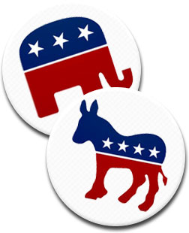
VIRTUAL GALLERY WALK - THE AMERICAN CAMPAIGN EXPERIENCE
Campaigns in the United States are part of our social fabric, and something that Americans have grown used to - but how do they work, and how are citizens affected by them? Do they change people's minds? Do they reflect reality? Visit each one of the sections below (in whatever order you want) and reflect on the media shown, played, or displayed for you. Respond to prompts as need by on a separate sheet - make sure you title each response section with the appropriate title of the topic section.
Citizen Attention
This clip from season 2 of The Simpsons has been described as a cynical, but accurate, example of how many elections function in the United States.
Bart Runs for Class President
Respond - In what ways can we see this short scene played out in American politics?
Media Portrayal of Campaigns
(Watch) Presidential Debate 2020
Respond - To what extent does this type of humor affect races? Does it mock the system and hurt the political process or does it bring more attention to the race? How are the candidates shown?
(Watch) 1996 Presidential Race SNL Skit
Respond - This skit was filmed many years before you were born and satire requires you know key elements about situations and personalities. What about this particular skit do you understand, and what elements do you not understand?
Oratory and Rhetoric on the Campaign Trail
(Watch)
Al Sharpton at the 2004 Democratic National Convention (link starts mid-way, watch through the end)
The Sharpton speech was supposed to be seven minutes, but he ditched the teleprompter and went off and simply spoke off the top of his head. The result was a wild success that galvanized the party. Respond - In what ways can you see quality oratory skills at work in the eight minutes that you see? What are key elements that allow him to connect with the delegates?
(Watch)
Pat Buchanan at the 1992 Republican National Convention (link starts mid-way, you may stop watching at the 23:00 mark)
Buchanan's "culture war" speech was so controversial that the GOP brass banned him from speaking at the 1996 convention, and Buchanan himself left the party in 2000 to run on the Reform party ticket. The speech was also widely credited with pulling down George H.W. Bush's election prospects.
Respond - How might a speech that appears to be very well received at the time(in house) turn out to haunt Republicans in this election and beyond? What rhetoric sticks with you in the section of the speech that you watched? (Btw- remember the context, George H.W. Bush was a moderate)
Horse Race Primary System
Review the Primaries going back to 1972 (those that actually had multiple people running)... primaries are considered horse races because the media follows closely on who is in the lead as the race goes from state to state. Momentum is king, but delegates matter most. Review one of the four available physical binders (available in class or PDF online on the website - the document is called "Horse Race Primary Analysis'") that show the competitive races.
Respond - Geography and ideology are key components on any primary strategy. Discuss some elements of the primaries that you found interesting. At least two to three paragraphs of reflections.
Campaign Slogans
Review the following site and analyze the campaign slogans of various Presidential candidates.
http://www.presidentsusa.net/campaignslogans.html
Respond - How effective are they about giving real information to voters? Are any of these, in your opinion, better than others in terms of having a positive political spin? Finally, name your favorite of the slogans and why you like it.
Elections and Campaigns in Political Cartoons
The following are all political cartoons that deal with various areas of discussion in terms of the U.S. election system and campaigning norms. Check em out!
Cartoon #1
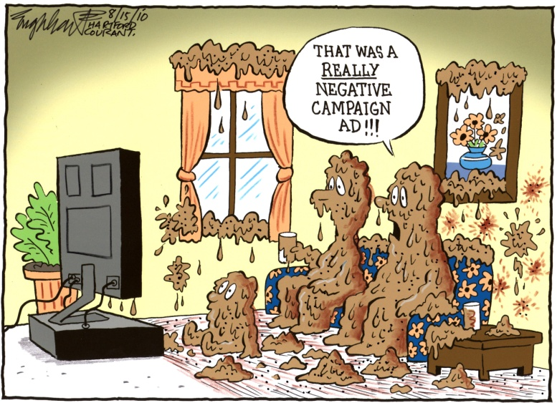
Cartoon #2 Cartoon #3
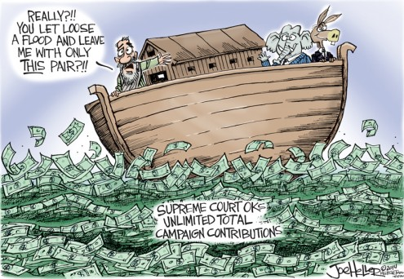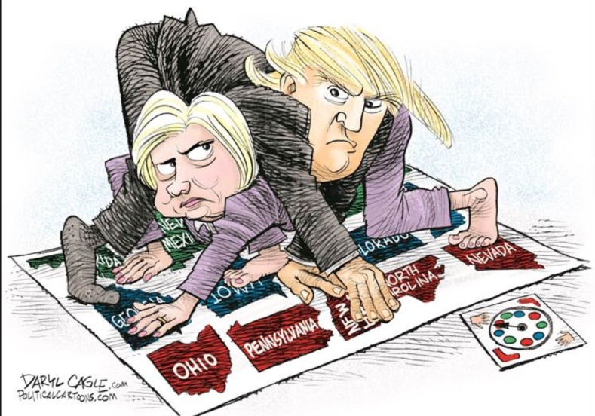
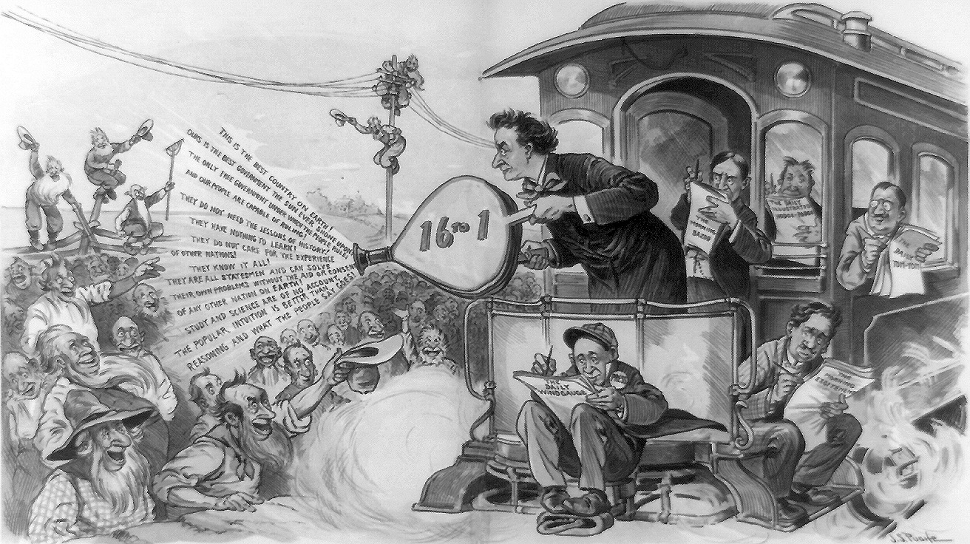
Cartoon #4

Respond - What do the following cartoons provide in terms of commentary on the U.S. campaigning universe?

